ELECENG 3CL4 – Lab 2
Closed-Loop System Identification

February 13th, 2026

Amaiam Ul Haque – haquea24 – 400520641 – L07 – C02
Jumana Ismail – ismailj – 400507846 – L07 – C02

Plagiarism Statement
As a future member of the engineering profession, the student is responsible for performing the required work in an honest manner, without plagiarism and cheating. Submitting this work with my name and student number is a statement and understanding that this work is my own and adheres to the Academic Integrity Policy of McMaster University and the Code of Conduct of the Professional Engineers of Ontario. Submitted by [Amaiam Ul-Haque, haquea24, 400520641]
As a future member of the engineering profession, the student is responsible for performing the required work in an honest manner, without plagiarism and cheating. Submitting this work with my name and student number is a statement and understanding that this work is my own and adheres to the Academic Integrity Policy of McMaster University and the Code of Conduct of the Professional Engineers of Ontario. Submitted by [Jumana Ismail, ismailj, 400507846]

Individual Contributions
Amaiam Ul-Haque: I did experiment 2 of the report and did the introduction.
Jumana Ismail: I did experiment 1 of the report and looked over the introduction and adjusted it.

Introduction
The objective of this lab was to experimentally find the transfer function model of a marginally stable servomotor. Using time-domain and frequency-domain identification techniques, motor parameters A and $τ_{m}$were obtained from a closed loop response system.

Experiment 1 - Time Domain Identification
For experiment 1, the objective was to find A and τm by finding the damping ratio, $ζ,$ and $ω_{n}$ from the experiment. To find the $ζ$ and $ω_{n}$, we worked with a closed loop with a proportional control K = 4 and applied a step input and measured how the output responded. With Simulink’s scope, the output position data was exported to the MATLAB workspace using the To Workspace block and plotted as a function of time.
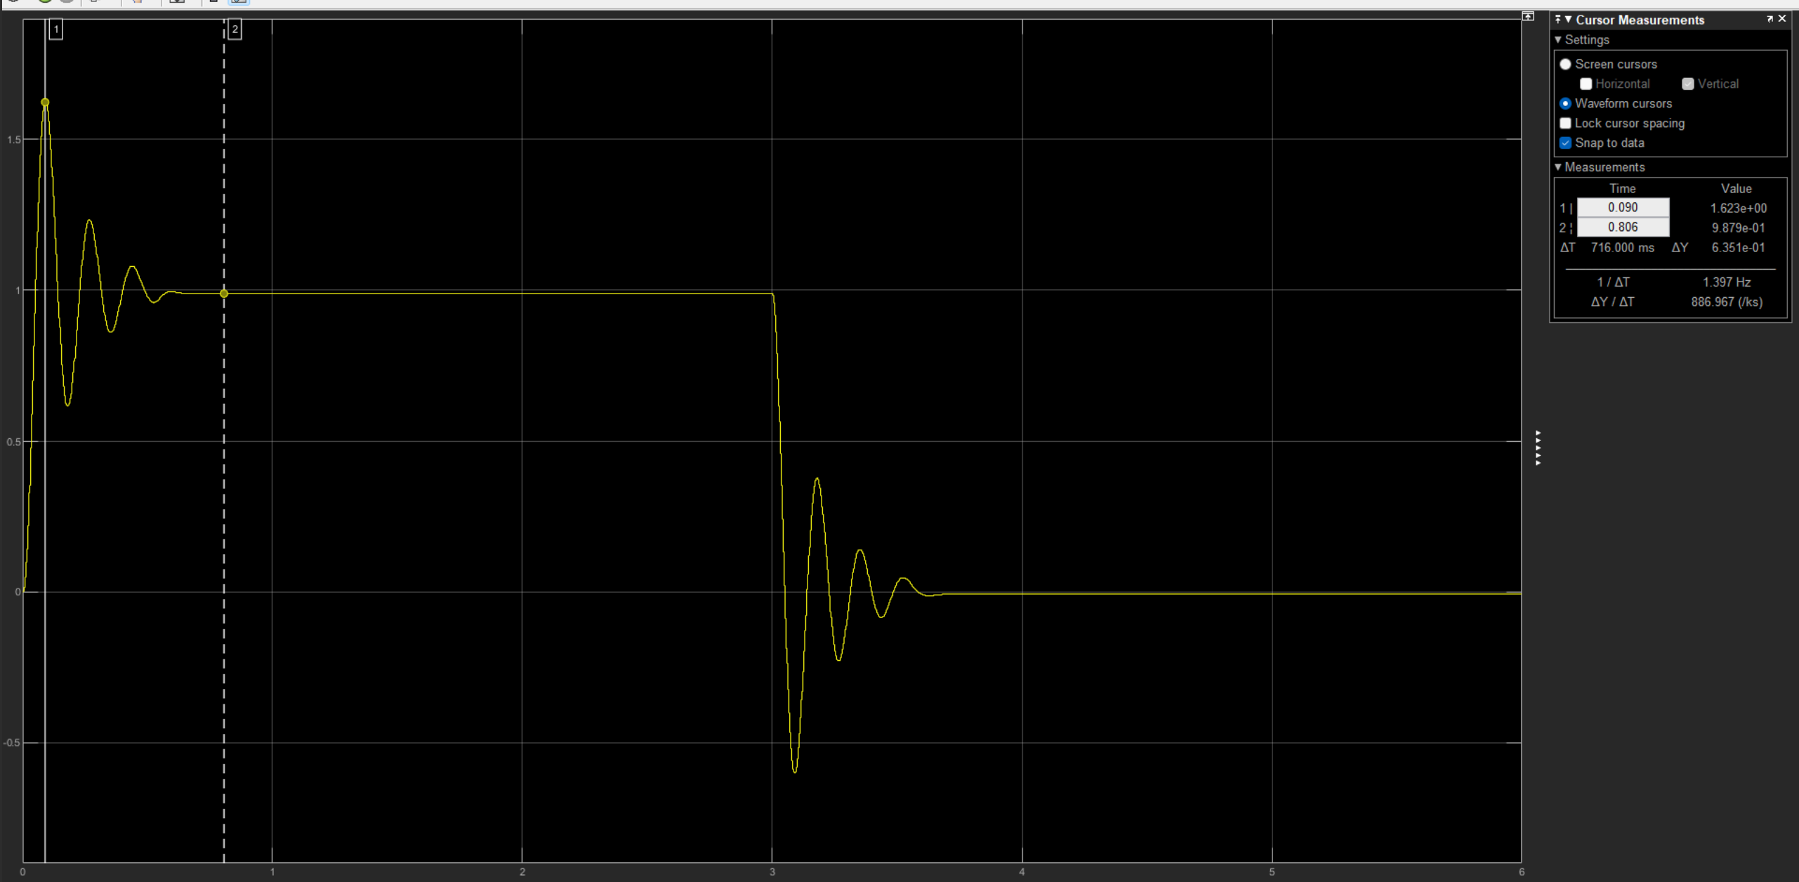 Figure 1: The Closed-loop step response of the motor in Time domain
As seen from the plot above, since we have an underdamped system, we see an oscillation for an underdamped second order response having a maximum overshoot value i.e. $M_{pt}$ is known to be the first peak of the second order underdamped system, which’s value was 1.623 rad. After the oscillations, the system reaches a steady state value. The steady state value was approximately 1 rad. Using these values, the percentage overshoot was calculated as:
$P.O. = \left[\left(M_{pt} - y_{ss}\right)÷y_{ss} \right] x 100$ = [(1.623 - 1) / 1 ] x 100 = 62.3%
The peak time Tp was measured to be the time at which the first peak took place. Using the cursor tool on the scope, it was found to be 0.090 s. Now, with P.O and $T_{p ,} ζ$ and $ω_{n}$ were found using the following equations below to find A and $τ_{m}$:
$ζ = \frac{\ln\left(\frac{P.O.}{100}\right)}{\sqrt{π^{2}+\ln^{2}\left(\frac{P.O.}{100}\right)}}$ => $ζ = \frac{\ln\left(\frac{62.3}{100}\right)}{\sqrt{π^{2}+\ln^{2}\left(\frac{62.3}{100}\right)}}$ => $ζ = 0.1504$
$ω_{n} = \frac{π}{T_{p\sqrt{1-ζ^{2}}}}$ => $ω_{n} = \frac{π}{\left(0.090\right)\sqrt{1-(0.150432)^2}}$ => $ω_{n} = 35.3083$ rad/s
$∴ τ_{m} = \frac{1}{2ω_{n}ζ}$ = $\frac{1}{2(35.3083)(0.150432)}$ = 0.0941 s, $A = \frac{\frac{ω_{n}}{2ζ}}{K}$ = $\frac{\frac{35.3083}{2(0.150432)}}{4}$ = 29.3392 rad/V*s
From Equation 3, the finalized transfer motor is:
$$G\left(s\right)=\frac{Θ\left(s\right)}{X\left(s\right)}= \frac{A}{s\left(sτm+1\right)}= \frac{29.3392}{s\left(0.0941s+1\right)}$$

Experiment 2 – Frequency Domain Identification
For the identification of the process’ transfer function, the following setup was used in Simulink:
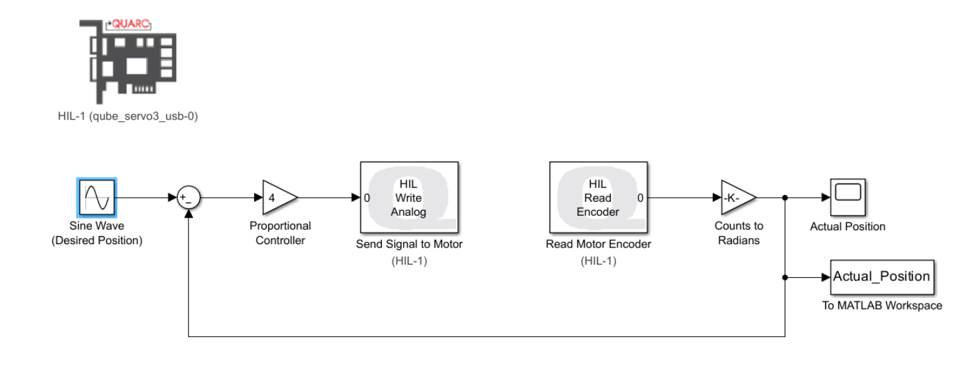
Figure 2. Simulink Setup
- The input r(t) was represented via a sine wave with an amplitude of 1, a phase of 0$°$, and a frequency of $2π×1 rad/s$.
- The proportionality constant of $K=4$.
The values of $M_{p}$ and $ω_{p}$ were experimentally determined via both a course grain search followed by a fine grain search. Below are the resulting tables respectively. The values of the output Amplitude were measured using the cursor tool on the Scope plot.
Frequency (rad/s) | Output Amplitude
$$2π×1$$ | 1.019
$$2π×2$$ | 1.135
$$2π×3$$ | 1.390
$$2π×4$$ | 1.856
$$2π×5$$ | 3.160
$$2π×6$$ | 2.522
$$2π×7$$ | 1.316
Frequency (rad/s) | Output Amplitude
$$2π×4.5$$ | 2.577
$$2π×4.6$$ | 2.663
$$2π×4.7$$ | 2.786
$$2π×4.8$$ | 2.915
$$2π×4.9$$ | 3.111
$$2π×5.0$$ | 3.160
$$2π×5.1$$ | 3.304
$$2π×5.2$$ | 3.381
$$2π×5.3$$ | 3.467
$$2π×5.4$$ | 3.390
$$2π×5.5$$ | 3.280

At the precise frequency of 2$π$ x 5.3 rad/s, the highest amplitude peak was found with a value of 3.467 rad as shown in the plot below. Thus, $M_{p}$ = 3.467 rad and $ω_{p}$ = 2$π$ x 5.3 rad/s.
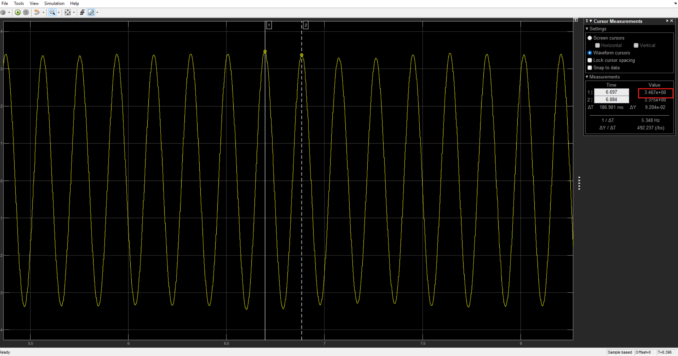
Figure 3. Measurement of maximum steady-state amplitude at resonant frequency
From the experimental values, $ζ$ and $ω_{n}$ were calculated to use them to find $τ_{m}$ and A as shown below:
$ζ = \sqrt{\frac{-4M_{p}^{2}±\sqrt{16M_{p}^{4}-16M_{p}^{2}}}{-8M_{p}^{2}}}$ = $\sqrt{\frac{-4(3.467)^2±\sqrt{16(3.467)^4-16(3.467)^2}}{-8(3.467)^2}}$ = 0.1458
$ω_{n = }\frac{ω_{p}}{\sqrt{1-2\left(\frac{-4M_{p}^{2} ± \sqrt{16M_{p}^{4}-16M_{p}^{2} }}{-8M_{p}^{2}}\right)}}$ = $\frac{2π x 5.3}{\sqrt{1-2\left(\frac{-4(3.467)^2±\sqrt{16(3.467)^4-16(3.467)^2}}{-8(3.467)^2}\right)}}$ = 34.03191 rad/s
$∴ τ_{m} = \frac{1}{2ω_{n}ζ}$ = $\frac{1}{2(34.03191)(0.1458)}$ = 0.1029 s, $A = \frac{\frac{ω_{n}}{2ζ}}{K}$ = $\frac{\frac{34.03191}{2(0.1458)}}{4}$ = 28.5552 rad/V*s

Therefore, the final motor transfer function is the following:
$$G\left(s\right)=\frac{Θ\left(s\right)}{X\left(s\right)}= \frac{A}{s\left(sτm+1\right)}= \frac{28.5552}{s\left(0.1029s+1\right)}$$

As seen from the overall lab, both the time domain and the frequency domain have very close A and $τm$values which verify the correctness of the results.

